**OMPython**

OpenModelica – Python API

User Manual

Version 1.0

March 2012

Copyright by

Open Source Modelica Consortium

Table of Contents

1 About OMPython 3

1.1 Features of OMPython 3

2 Pre-requisites 4

3 Using OMPython API 5

3.1 Test commands 5

3.2 Import as Library 5

3.2.1 Retrieve results from nested dictionaries 6

3.2.2 Set values to nested dictionaries 7

3.2.3 Example 8

4 The OMPython API 9

4.1 Implementation 9

4.1.1 Client 9

4.1.2 Parser 9

5 Examples 14

5.1 Import as Library 14

5.2 Test Commands 16

6 List of Commands 17

6.1 Additional resources 43

# About OMPython

OMPython – OpenModelica Python Interface is a free, open source, highly portable Python based interactive session handler for Modelica scripting. It provides the modeler with components for creating a complete Modelica modeling, compilation and simulation environment based on the latest OpenModelica library standard available. OMPython is architectured to combine both the solving strategy and model building. So domain experts (people writing the models) and computational engineers (people writing the solver code) can work on one unified tool that is industrially viable for optimization of Modelica models, while offering a flexible platform for algorithm development and research. OMPython v1.0 is not a standalone package, it depends upon the OpenModelica installation.

OMPython v1.0 is implemented in Python using the OmniORB and OmniORBpy – high performance CORBA ORBs for Python and it supports the Modelica Standard Library version 3.2 that is included in the latest OpenModelica (version 1.8.1) installation.

## Features of OMPython

OMPython provides user friendly features like,

* Interactive session handling, parsing, interpretation of commands and Modelica expressions for evaluation, simulation, plotting, etc.
* Interface to the latest OpenModelica API calls.
* Optimized parser results that give control over every element of the output.
* Helper functions to allow manipulation on Nested dictionaries.
* Easy access to the library and testing of OpenModelica commands.

# Pre-requisites

* + **OpenModelica1.8.1**

OMPython is bundled with OpenModelica from the nightly build revision 11480 and up.

<http://www.openmodelica.org/index.php/download>

* + **Python 2.7**

<http://www.python.org/download/>

# Using OMPython API

The third party library of OMPython can be created by changing directory to,

*\OpenModelica1.8.x\share\omc\scripts\PythonInterface*

and running the command,

python setup.py install

This will install the OMPython library into your *Python.xy/Lib/site-packages*

Now OMPython can be imported and used within Python.

## Test commands

To test the command outputs, simply import the OMPython library from Python and execute the run() method of OMPython.

The module allows you to iteratively send commands to the OMC server and display their output.

*For example:*

**C:\>python**

**>>> import OMPython**

**>>> OMPython.run()**

**>>**

*Full example:*

**C:\>python**

**>>> import OMPython**

**>>> OMPython.run()**

**>>loadModel(Modelica)**

**True**

## Import as Library

To use the module from within another python program, simply import OMPython from within the using program.

Make use of the execute() function of the OMPython library to send commands to the OMC server.

*For example:*

**answer = OMPython.execute(cmd)**

*Full example:*

**# test.py**

**import OMPython**

**cmds =**

**["loadModel(Modelica)",**

**"model test end test;",**

**"loadFile(\"C:/OpenModelica1.8.1/testmodels/BouncingBall.mo\")",**

**"getIconAnnotation(Modelica.Electrical.Analog.Basic.Resistor)",**

**"getElementsInfo(Modelica.Electrical.Analog.Basic.Resistor)",**

**"simulate(BouncingBall)",**

**"plot(h)"]**

**for cmd in cmds:**

**answer = OMPython.execute(cmd)**

**print "\nResult:\n%s"%answer**

### Retrieve results from nested dictionaries

Once the result is available from the OMPython.execute(), the OMPython.get() method can be used to retrieve and use specific values inside the dictionaries by simply querying the result dictionary with a string of nested dictionary names (keys).

The query should define the complete nested structure of the dictionary starting from its root.

*Syntax:*

OMPython.get(*dict, "dotted.dict.structure"*)

*For example:*

OMPython.execute("loadModel(Modelica)")

result= OMPython.execute("getIconAnnotation(Modelica.Electrical.Analog.Basic.Resistor)")

**inner = OMPython.get(result,'SET2.Elements.Line1.Properties')**

*Full example:*

**#test.py**

**import OMPython**

**OMPython.execute("loadModel(Modelica)")**

**result= OMPython.execute("getIconAnnotation(Modelica.Electrical.Analog.Basic.Resistor)")**

**inner = OMPython.get(result,'SET2.Elements.Line1.Properties')**

**print "result of get is \n%s" %inner**

### Set values to nested dictionaries

New dictionaries can be added to the existing nested dictionary by using the,

OMPyhton.set() method.

*Syntax:*

OMPython.set(dict,"new.dotted.dict.structure", new_value)

*Note:* new_value can be any of the Python supported datatypes.

*For example:*

OMPython.execute("loadModel(Modelica)")

result= OMPython.execute("getIconAnnotation(Modelica.Electrical.Analog.Basic.Resistor)")

**value = OMPython.set(result,"SET2.Elements.Line1.Properties.NEW", 1e-05)**

The OMPython.set() method does not append dictionaries to the existing nest but creates new ones inside the existing. Design your query such that you don't overwrite the dictionaries if you don’t intend to.

*Full example:*

**#test.py**

**import OMPython**

**OMPython.execute("loadModel(Modelica)")**

**result = OMPython.execute("getIconAnnotation(Modelica.Electrical.Analog.Basic.Resistor)")**

**inner = OMPython.get(result,'SET2.Elements.Line1.Properties')**

**print "result of get is \n%s" %inner**

**value = OMPython.set(result,"SET2.Elements.Line1.Properties.NEW", [1,2,3])**

**print "Result:: \n%s" % OMPython.get(value,'SET2.Elements.Line1.Properties.NEW')**

### Example

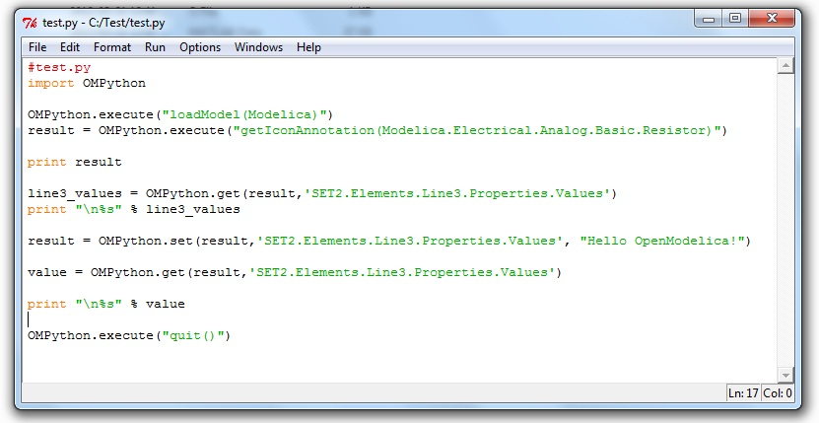

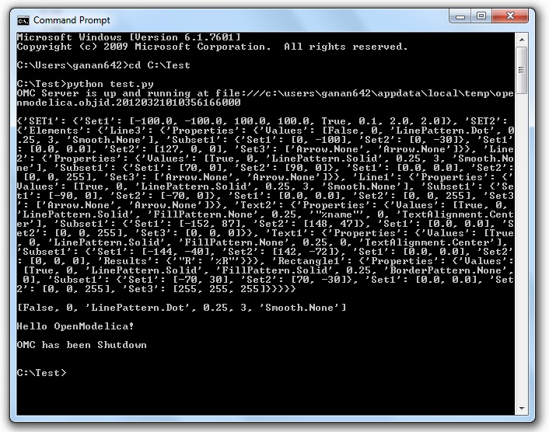

# The OMPython API

## Implementation

### Client

The OpenModelica-Python API Interface – OMPython, attempts to mimic the OmShell's style of operations.

OMPython is designed to,

* Initialize the CORBA communication
* Send commands to the Omc server via the CORBA interface
* Receive the string results.
* Use the Parser module to format the results
* Return or display the results.

### Parser

Since the results of OMC are retrieved in a String format over CORBA, some housekeeping has to be done to make sure the results are usable in Python easily.

The Parser is designed to do the following,

* Analyze the result string for categorical data.
* Group each category under a category name
* Type cast the data within these categories
* Build a suitable data structure to hold these data so that the results can be easily accessed and used.

#### Understanding the Parsed output

Each command in OpenModelica produces a result that can be categorized according to the statistics of the pattern of data presented in the text. Grammar based parsers were found to be tedious to use because of the complexity of the patterns of data.

The parser just type casts the data without "curly brackets" to the appropriate data type and displays it as the result.

*For example:*

>>getVectorizationLimit()

20

>>getNthInheritedClass(Modelica.Electrical.Analog.Basic.Resistor,1)

Modelica.Electrical.Analog.Interfaces.OnePort

However, multiple data types packed within a pair of quotations is always treated as a full string.

*For example:*

>>getModelicaPath()

"C:/OpenModelica1.8.0/lib/omlibrary"

##### The Dictionary data type in Python:

Dictionaries are found to be a useful datatype to pack data with different datatypes. Dictionaries in Python are indexed by Keys unlike the sequences, which are indexed by a range of numbers.

It is best to think of dictionaries as an unordered set of ***key:value*** pairs, with the requirement that the keys are always unique. The common operation on dictionaries is to store a value associated with a key and retrieve the value using the key. This provides us the flexibility of creating keys at runtime and accessing these values using their keys later. All data within the dictionary are stored inside a named dictionary. An empty dictionary is represented by a pair of braces **{}**.

From the reply of the OMC, the complicated result strings are usually the ones found within the curly braces, in order to make a meaningful categorization of the data within these brackets and to avoid the potential complexities due to creating Dynamic variables, we introduce the following notations that can be used within dictionaries,

* SET
* Set
* Subset
* Element
* Results
* Values

##### SET

A SET (*note the capital letters*) is used to group data that belong to the first set of balanced curly brackets. According to the needed semantics of the results, a SET can contain ***Sets, Subsets, Elements, Values and Results***. A SET can also be empty, denoted by **{}**. The SETs are named with an increasing index starting from 1(one). This feature was planned to eliminate the need for dynamic variable creation and having duplicate Keys. The SET belongs within the dictionary, result.

*For example:*

>>strtok("abcbdef","b")

{'SET1': {'Values': ['"a","c","def"']}}

The command strtok tokenizes the string "abcbdef" at every occurrence of b and produces a SET with values "a", "c", "def".

##### Set

A set is used to group all data within the a SET that is enclosed within a pair of balanced {}s. A Set can contain only Values and Elements. A set can also be empty, it can be depicted as **{{}}**, the outer brackets compose a SET, the inner brackets are the Set within the SET.

##### Subset

A Subset is a two-level deep set that is found within a SET. A subset can contain multiple Sets within its enclosure.

*For example:*

**{***SET1* **{***Subset1***{***Set1***},{***Set2***},{***Set3***}}}**

##### Element

Elements are the data which are grouped within a pair of Parenthesis ( ). As observed from the results string, elements have an element name that describes the data within them, so elements can be grouped by their names. Also, many elements have the same names, so they are indexed by increasing numbers starting from 1(one). Elements have the special property of having one or more Sets and Subsets within them. However, they are in turn enclosed within the SET.

*For example:*

*>>getClassAttributes(test.mymodel)*

*{'****SET1'****: {****'Elements':*** *{'****rec1':*** *{****'Properties':*** *{****'Results':*** *{'comment': None, 'res*

*triction': 'MODEL', 'startLine': 1, 'partial': False, 'name': '"mymodel"', 'enca*

*psulated': False, 'startColumn': 14, 'readonly': '"writable"', 'endColumn': 69,*

*'file': '"<interactive>"', 'endLine': 1, 'final': False}}}}}}*

*The result contains, a SET with a Element named rec1 which has Properties which are Results (see below) of the element.*

##### Results

Data that is related by the assignment operator "=", within the SETs are denoted as Results. These assignments cannot be assigned to their actual values unless they are related by a Name = Value relationship. So, they form the sub-dictionary called Results within the Element (for example). Then these values can be related by the ***key:value*** pair relationship.

*For example:*

*>>getClassAttributes(test.mymodel)*

*{'SET1': {'Elements': {'rec1': {'Properties': {****'Results':*** *{****'comment': None, 'res***

***triction': 'MODEL', 'startLine': 1, 'partial': False, 'name': '"mymodel"', 'enca***

***psulated': False, 'startColumn': 14, 'readonly': '"writable"', 'endColumn': 69,***

***'file': '"<interactive>"', 'endLine': 1, 'final': False****}}}}}}*

##### Values

Data within any or all of SETs, Sets, Elements and Subsets that are not assignments and separated by commas are grouped together into a list called "Values". The Values list may also be empty, due to Python's representation of a null string "" as {}. Although a Null string is still a Null value, sometimes it is possible to observe data grouped into Values to look like Sets within the Values list.

*For example:*

*>>getNthConnection(Modelica.Electrical.Analog.Examples.ChuaCircuit,2)*

*{'SET1': {'Set1': ['G.n', 'Nr.p', {}]}}*

##### The Simulation results

The simulate() command produces output that has no SET or Set data in it. Instead, for simplicity, it has two dictionaries namely, SimulationResults and SimulationOptions within the result dictionary.

*For example:*

**OMPython.execute("simulate(BouncingBall)")**

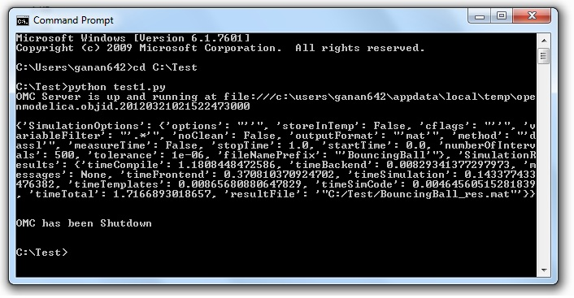

##### Record Constructs

The OpenModelica commands that produce output with Record constructs also do not have SET or Set data within them. The results of the output are packed within the RecordResults dictionary.

*For example:*

**OMPython.execute("checkSettings()")**

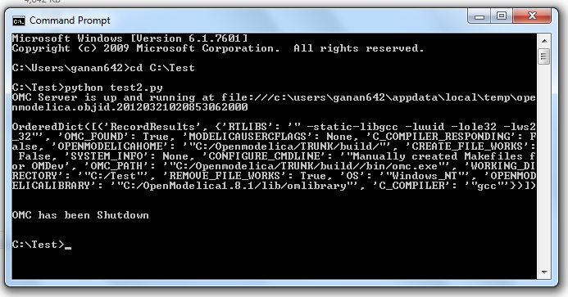

# Examples

## Import as Library

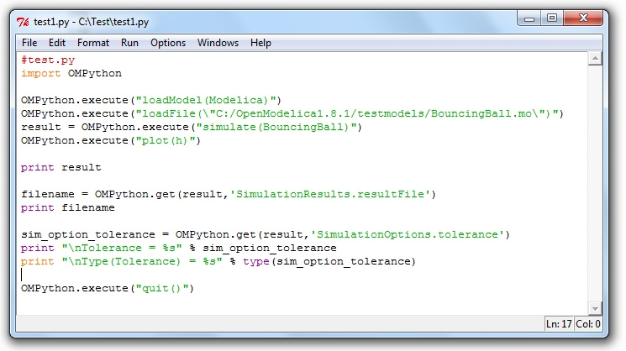

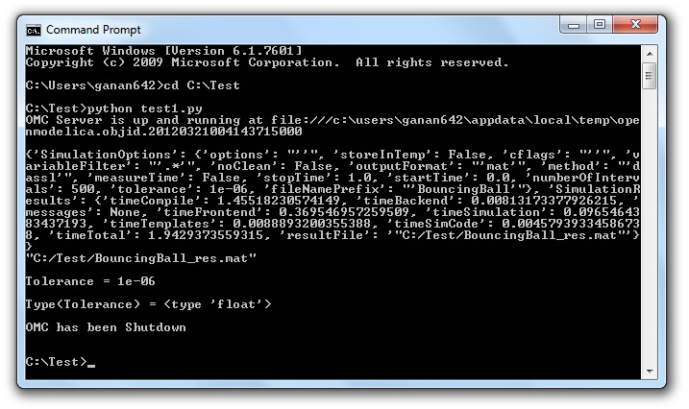

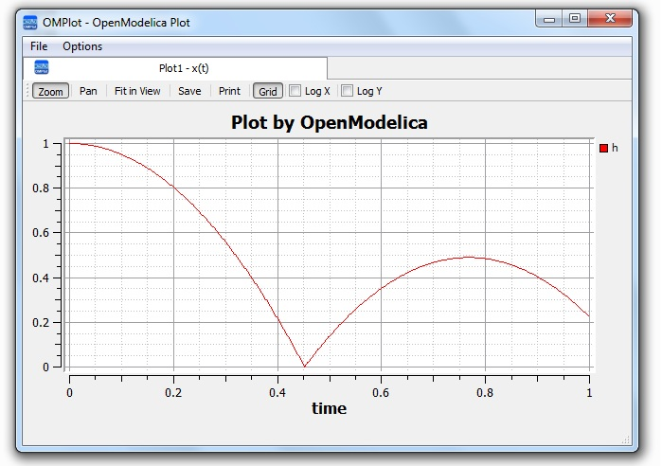

## Test Commands

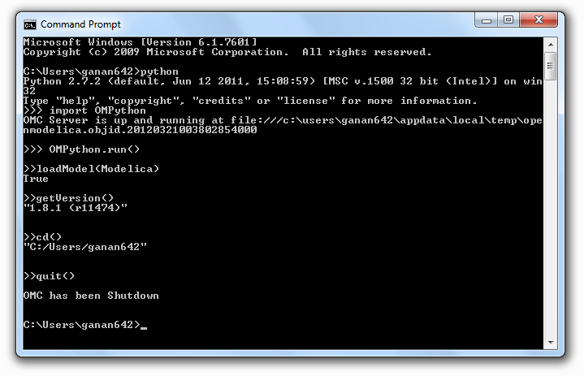

# List of Commands

The following table contains brief descriptions about the commands that are available in the OpenModelica environment.

|  |  |
| --- | --- |
| **Name** | **Description** |
| **simulate** | Simulate model, optionally setting simulation values.*Inputs*: TypeName className; Real startTime;  Real stopTime; Integer numberOfIntervals;  Real outputInterval; String method;  Real tolerance; Real fixedStepSize;  *Outputs*: SimulationResult simRes; |
| **appendEnvironmentVar** | Interface function appendEnvironmentVar  input String var;  input String value;  output String result "returns \"error\" if the variable could not be appended";  end appendEnvironmentVar; |
| **basename** | Returns the base name (file part) of a file path. Similar to [basename(3)](http://linux.die.net/man/3/basename), but with the safety of Modelica strings. Interface function basename  input String path;  output String basename;  end basename; |
| **Cd** | change directory to the given path (which may be either relative or absolute) returns the new working directory on success or a message on failure if the given path is the empty string, the function simply returns the current working directory Interface function cd  input String newWorkingDirectory = "";  output String workingDirectory;  end cd; |
| **checkAllModelsRecursive** | Interface function checkAllModelsRecursive  input TypeName className;  input Boolean checkProtected = false "Checks also protected classes if true";  output String result;  end checkAllModelsRecursive; |
| **checkModel** | Instantiate model, optimize equations, and report errors.Interface function checkModel  input TypeName className;  output String result;  end checkModel; |
| **checkSettings** | Display some diagnostics Interface function checkSettings  output CheckSettingsResult result;  end checkSettings; |
| **clear** | Clears everything: symboltable and variables.Interface function clear  output Boolean success;  end clear; |
| **clearMessages** | Clears the error buffer Interface function clearMessages  output Boolean success;  end clearMessages; |
| **clearVariables** | Clear all user defined variables.Interface function clearVariables  output Boolean success;  end clearVariables; |
| **closeSimulationResultFile** | Closes the current simulation result file. Only needed by Windows. Windows cannot handle reading and writing to the same file from different processes. To allow OMEdit to make successful simulation again on the same file we must close the file after reading the Simulation Result Variables. Even OMEdit only use this API for Windows Interface function closeSimulationResultFile  output Boolean success;  end closeSimulationResultFile |
| **codeToString** | Interface function codeToString  input Code className;  output String string;  end codeToString; |
| **compareSimulationResults** | Compare simulation results Interface function compareSimulationResults  input String filename;  input String reffilename;  input String logfilename;  input Real refTol;  input Real absTol;  input String[:] vars;  output String result;  end compareSimulationResults; |
| **deleteFile** | Deletes a file with the given name Interface function deleteFile  input String fileName;  output Boolean success;  end deleteFile; |
| **dirname** | Returns the directory name of a file path. Similar to [dirname(3)](http://linux.die.net/man/3/dirname), but with the safety of Modelica strings. Interface function dirname  input String path;  output String dirname;  end dirname; |
| **dumpXMLDAE** | Interface function dumpXMLDAE  input TypeName className;  input String translationLevel = "flat";  input Boolean addOriginalIncidenceMatrix = false;  input Boolean addSolvingInfo = false;  input Boolean addMathMLCode = false;  input Boolean dumpResiduals = false;  input String fileNamePrefix = "<default>" "this is the className in string form by default";  input Boolean storeInTemp = false;  output String result[2] "Contents, Message/Filename; why is this an array and not 2 output arguments?";  end dumpXMLDAE; |
| **Echo** | echo(false) disables Interactive output, echo(true) enables it again. Interface function echo  input Boolean setEcho;  output Boolean newEcho;  end echo; |
| **generateCode** | The input is a function name for which C-code is generated and compiled into a dll/so Interface function generateCode  input TypeName className;  output Boolean success;  end generateCode; |
| **generateHeader** | Interface function generateHeader  input String fileName;  output Boolean success;  end generateHeader; |
| **generateSeparateCode** | Interface function generateSeparateCode  output Boolean success;  end generateSeparateCode; |
| **getAlgorithmCount** | Counts the number of Algorithm sections in a class Interface function getAlgorithmCount  input TypeName class_;  output Integer count;  end getAlgorithmCount; |
| **getAlgorithmItemsCount** | Counts the number of Algorithm items in a class Interface function getAlgorithmItemsCount  input TypeName class_;  output Integer count;  end getAlgorithmItemsCount; |
| **getAnnotationCount** | Counts the number of Annotation sections in a class Interface function getAnnotationCount  input TypeName class_;  output Integer count;  end getAnnotationCount; |
| **getAnnotationVersion** | Interface function getAnnotationVersion  output String annotationVersion;  end getAnnotationVersion; |
| **getAstAsCorbaString** | Print the whole AST on the CORBA format for records, e.g.  record Absyn.PROGRAM  classes = ...,  within_ = ...,  globalBuildTimes = ...  end Absyn.PROGRAM; Interface function getAstAsCorbaString  input String fileName = "<interactive>";  output String result "returns the string if fileName is interactive; else it returns ok or error depending on if writing the file succeeded";  end getAstAsCorbaString; |
| **getClassComment** | Interface function getClassComment  input TypeName cl;  output String comment;  end getClassComment; |
| **getClassNames** | Interface function getClassNames  input TypeName class_ = Code(AllLoadedClasses);  input Boolean recursive = false;  input Boolean qualified = false;  input Boolean sort = false;  input Boolean builtin = false "List also builtin classes if true";  input Boolean showProtected = false "List also protected classes if true";  output TypeName classNames[:];  end getClassNames; |
| **getClassesInModelicaPath** | Interface function getClassesInModelicaPath  output String classesInModelicaPath;  end getClassesInModelicaPath; |
| **getCompileCommand** | Interface function getCompileCommand  output String compileCommand;  end getCompileCommand; |
| **getDocumentationAnnotation** | Interface function getDocumentationAnnotation  input TypeName cl;  output String out[2] "{info,revision}";  end getDocumentationAnnotation; |
| **getEnvironmentVar** | Interface function getEnvironmentVar  input String var;  output String value "returns empty string on failure";  end getEnvironmentVar; |
| **getEquationCount** | Counts the number of Equation sections in a class Interface function getEquationCount  input TypeName class_;  output Integer count;  end getEquationCount; |
| **getEquationItemsCount** | Counts the number of Equation items in a class Interface function getEquationItemsCount  input TypeName class_;  output Integer count;  end getEquationItemsCount;  ounts the number of Equation items in a class |
| **getErrorString** | [file.mo:n:n-n:n:b] Error: message Interface function getErrorString  output String errorString;  end getErrorString; |
| **getImportCount** | Counts the number of Import sections in a class Interface function getImportCount  input TypeName class_;  output Integer count;  end getImportCount; |
| **getInitialAlgorithmCount** | Counts the number of Initial Algorithm sections in a class Interface function getInitialAlgorithmCount  input TypeName class_;  output Integer count;  end getInitialAlgorithmCount; |
| **getInitialAlgorithmItemsCount** | Counts the number of Initial Algorithm items in a class Interface function getInitialAlgorithmItemsCount  input TypeName class_;  output Integer count;  end getInitialAlgorithmItemsCount; |
| **getInitialEquationCount** | Counts the number of Initial Equation sections in a class Interface function getInitialEquationCount  input TypeName class_;  output Integer count;  end getInitialEquationCount; |
| **getInitialEquationItemsCount** | Counts the number of Initial Equation items in a class Interface function getInitialEquationItemsCount  input TypeName class_;  output Integer count;  end getInitialEquationItemsCount; |
| **getInstallationDirectoryPath** | This returns OPENMODELICAHOME if it is set; on some platforms the default path is returned if it is not set. Interface function getInstallationDirectoryPath  output String installationDirectoryPath;  end getInstallationDirectoryPath; |
| **getLanguageStandard** | Interface function getLanguageStandard  output String outVersion;  end getLanguageStandard; |
| **getMessagesString** | see getErrorString() Interface function getMessagesString  output String messagesString;  end getMessagesString; |
| **getMessagesStringInternal** | {{[file.mo:n:n-n:n:b] Error: message, TRANSLATION, Error, code}} Interface function getMessagesStringInternal  output ErrorMessage[:] messagesString;  end getMessagesStringInternal; |
| **getModelicaPath** | See [loadModel()](http://build.openmodelica.org/Documentation/OpenModelica.Scripting.loadModel.html) for a description of what the MODELICAPATH is used for. Interface function getModelicaPath  output String modelicaPath;  end getModelicaPath; |
| **getNoSimplify** | Interface function getNoSimplify  output Boolean noSimplify;  end getNoSimplify; |
| **getNthAlgorithm** | Returns the Nth Algorithm section Interface function getNthAlgorithm  input TypeName class_;  input Integer index;  output String result;  end getNthAlgorithm; |
| **getNthAlgorithmItem** | Returns the Nth Algorithm Item Interface function getNthAlgorithmItem  input TypeName class_;  input Integer index;  output String result;  end getNthAlgorithmItem; |
| **getNthAnnotationString** | Returns the Nth Annotation section as string Interface function getNthAnnotationString  input TypeName class_;  input Integer index;  output String result;  end getNthAnnotationString; |
| **getNthEquation** | Returns the Nth Equation section Interface function getNthEquation  input TypeName class_;  input Integer index;  output String result;  end getNthEquation; |
| **getNthEquationItem** | Returns the Nth Equation Item Interface function getNthEquationItem  input TypeName class_;  input Integer index;  output String result;  end getNthEquationItem; |
| **getNthImport** | Returns the Nth Import as string Interface function getNthImport  input TypeName class_;  input Integer index;  output String out[3] "{\"Path\",\"Id\",\"Kind\"}";  end getNthImport; |
| **getNthInitialAlgorithm** | Returns the Nth Initial Algorithm section Interface function getNthInitialAlgorithm  input TypeName class_;  input Integer index;  output String result;  end getNthInitialAlgorithm; |
| **getNthInitialAlgorithmItem** | Returns the Nth Initial Algorithm Item Interface function getNthInitialAlgorithmItem  input TypeName class_;  input Integer index;  output String result;  end getNthInitialAlgorithmItem; |
| **getNthInitialEquation** | Returns the Nth Initial Equation section Interface function getNthInitialEquation  input TypeName class_;  input Integer index;  output String result;  end getNthInitialEquation; |
| **getNthInitialEquationItem** | Returns the Nth Initial Equation Item Interface function getNthInitialEquationItem  input TypeName class_;  input Integer index;  output String result;  end getNthInitialEquationItem;  ns the Nth Initial Equation Item |
| **getOrderConnections** | Interface function getOrderConnections  output Boolean orderConnections;  end getOrderConnections; |
| **getPackages** | Interface function getPackages  input TypeName class_ = Code(AllLoadedClasses);  output TypeName classNames[:];  end getPackages; |
| **getPlotSilent** | Interface function getPlotSilent  output Boolean plotSilent;  end getPlotSilent; |
| **getSettings** | Interface function getSettings  output String settings;  end getSettings; |
| **getShowAnnotations** | Interface function getShowAnnotations  output Boolean show;  end getShowAnnotations; |
| **getSourceFile** | Interface function getSourceFile  input TypeName class_;  output String filename "empty on failure";  end getSourceFile; |
| **getTempDirectoryPath** | Interface function getTempDirectoryPath  output String tempDirectoryPath;  end getTempDirectoryPath; |
| **getVectorizationLimit** | Interface function getVectorizationLimit  output Integer vectorizationLimit;  end getVectorizationLimit; |
| **getVersion** | Returns the version of the Modelica compiler Interface function getVersion  input TypeName cl = Code(OpenModelica);  output String version;  end getVersion; |
| **help** | Display the OpenModelica help text Interface function help  output String helpText;  end help; |
| **iconv** | The iconv() function converts one multibyte characters from one character  set to another.  See man (3) iconv for more information. Interface function iconv  input String string;  input String from;  input String to = "UTF-8";  output String result;  end iconv; |
| **importFMU** | Imports the Functional Mockup Unit  Example command:  importFMU("A.fmu"); Interface function importFMU  input String filename "the fmu file name";  input String workdir = "./" "The output directory for imported FMU files. <default> will put the files to current working directory.";  output Boolean success "Returns true on success";  end importFMU; |
| **instantiateModel** | Instantiate model, resulting in a .mof file of flattened Modelica.Interface function instantiateModel  input TypeName className;  output String result;  end instantiateModel; |
| **isModel** | Returns true if the given class has restriction model. Interface function isModel  input TypeName cl;  output Boolean b;  end isModel; |
| **isPackage** | Returns true if the given class is a package. Interface function isPackage  input TypeName cl;  output Boolean b;  end isPackage; |
| **isPartial** | Returns true if the given class is partial. Interface function isPartial  input TypeName cl;  output Boolean b;  end isPartial; |
| **list** | Pretty-prints a class definition. Syntax **list**(Modelica.Math.sin)  **list**(Modelica.Math.sin,interfaceOnly=true) Interface function list  input TypeName class_ = Code(AllLoadedClasses);  input Boolean interfaceOnly = false;  input Boolean shortOnly = false "only short class definitions";  output String contents;  end list; |
| **listVariables** | Lists the names of the active variables in the scripting environment. Interface function listVariables  output TypeName variables[:];  end listVariables; |
| **loadFile** | load file (*.mo) and merge it with the loaded AST Interface function loadFile  input String fileName;  output Boolean success;  end loadFile; |
| **loadFileInteractive** | Interface function loadFileInteractive  input String filename;  output TypeName names[:];  end loadFileInteractive; |
| **loadFileInteractiveQualified** | Interface function loadFileInteractiveQualified  input String filename;  output TypeName names[:];  end loadFileInteractiveQualified; |
| **loadModel** | Loads a Modelica library. Syntax **loadModel**(Modelica)  **loadModel**(Modelica,{"3.2"}) Interface function loadModel  input TypeName className;  input String[:] priorityVersion = {"default"};  output Boolean success;  end loadModel; |
| **loadString** | Parses the data and merges the resulting AST with the  loaded AST.  If a filename is given, it is used to provide error-messages as if the string  was read in binary format from a file with the same name.  The file is converted to UTF-8 from the given character set.   Interface function loadString  input String data;  input String filename = "<interactive>";  input String encoding = "UTF-8";  output Boolean success;  end loadString; |
| **parseFile** | Interface function parseFile  input String filename;  output TypeName names[:];  end parseFile; |
| **parseString** | Interface function parseString  input String data;  input String filename = "<interactive>";  output TypeName names[:];  end parseString; |
| **plot** | Launches a plot window using OMPlot. Returns true on success.  Don't require sendData support.    Example command sequences:  simulate(A);plot({x,y,z});  simulate(A);plot(x, externalWindow=true);  simulate(A,fileNamePrefix="B");simulate(C);plot(z,"B.mat",legend=false);   Interface function plot  input VariableNames vars "The variables you want to plot";  input Boolean externalWindow = false "Opens the plot in a new plot window";  input String fileName = "<default>" "The filename containing the variables. <default> will read the last simulation result";  input String title = "Plot by OpenModelica" "This text will be used as the diagram title.";  input Boolean legend = true "Determines whether or not the variable legend is shown.";  input Boolean grid = true "Determines whether or not a grid is shown in the diagram.";  input Boolean logX = false "Determines whether or not the horizontal axis is logarithmically scaled.";  input Boolean logY = false "Determines whether or not the vertical axis is logarithmically scaled.";  input String xLabel = "time" "This text will be used as the horizontal label in the diagram.";  input String yLabel = "" "This text will be used as the vertical label in the diagram.";  input Real xRange[2] = {0.0,0.0} "Determines the horizontal interval that is visible in the diagram. {0,0} will select a suitable range.";  input Real yRange[2] = {0.0,0.0} "Determines the vertical interval that is visible in the diagram. {0,0} will select a suitable range.";  output Boolean success "Returns true on success";  output String[:] result "Returns list i.e {\"_omc_PlotResult\",\"<fileName>\",\"<title>\",\"<legend>\",\"<grid>\",\"<PlotType>\",\"<logX>\",\"<logY>\",\"<xLabel>\",\"<yLabel>\",\"<xRange>\",\"<yRange>\",\"<PlotVariables>\"}";  end plot; |
| **plot2** | Uses the Java-based plot window (ptplot.jar) to launch a plot,  similar to the plot() command. This command accepts fewer options, but works  even when OpenModelica was not compiled with sendData support.    Example command sequences:  simulate(A);plot2({x,y});  simulate(A,fileNamePrefix="B");simulate(C);plot2(x,"B.mat");   Interface function plot2  input VariableNames vars;  input String fileName = "<default>";  output Boolean success "Returns true on success";  end plot2; |
| **plotAll** | Works in the same way as plot(), but does not accept any  variable names as input. Instead, all variables are part of the plot window.    Example command sequences:  simulate(A);plotAll();  simulate(A);plotAll(externalWindow=true);  simulate(A,fileNamePrefix="B");simulate(C);plotAll(x,"B.mat"); Interface function plotAll  input Boolean externalWindow = false "Opens the plot in a new plot window";  input String fileName = "<default>" "The filename containing the variables. <default> will read the last simulation result";  input String title = "Plot by OpenModelica" "This text will be used as the diagram title.";  input Boolean legend = true "Determines whether or not the variable legend is shown.";  input Boolean grid = true "Determines whether or not a grid is shown in the diagram.";  input Boolean logX = false "Determines whether or not the horizontal axis is logarithmically scaled.";  input Boolean logY = false "Determines whether or not the vertical axis is logarithmically scaled.";  input String xLabel = "time" "This text will be used as the horizontal label in the diagram.";  input String yLabel = "" "This text will be used as the vertical label in the diagram.";  input Real xRange[2] = {0.0,0.0} "Determines the horizontal interval that is visible in the diagram. {0,0} will select a suitable range.";  input Real yRange[2] = {0.0,0.0} "Determines the vertical interval that is visible in the diagram. {0,0} will select a suitable range.";  output Boolean success "Returns true on success";  output String[:] result "Returns list i.e {\"_omc_PlotResult\",\"<fileName>\",\"<title>\",\"<legend>\",\"<grid>\",\"<PlotType>\",\"<logX>\",\"<logY>\",\"<xLabel>\",\"<yLabel>\",\"<xRange>\",\"<yRange>\",\"<PlotVariables>\"}";  end plotAll; |
| **plotParametric** | Launches a plotParametric window using OMPlot. Returns true on success.  Don't require sendData support.    Example command sequences:  simulate(A);plotParametric2(x,y);  simulate(A);plotParametric2(x,y, externalWindow=true);   Interface function plotParametric  input VariableName xVariable;  input VariableName yVariable;  input Boolean externalWindow = false "Opens the plot in a new plot window";  input String fileName = "<default>" "The filename containing the variables. <default> will read the last simulation result";  input String title = "Plot by OpenModelica" "This text will be used as the diagram title.";  input Boolean legend = true "Determines whether or not the variable legend is shown.";  input Boolean grid = true "Determines whether or not a grid is shown in the diagram.";  input Boolean logX = false "Determines whether or not the horizontal axis is logarithmically scaled.";  input Boolean logY = false "Determines whether or not the vertical axis is logarithmically scaled.";  input String xLabel = "time" "This text will be used as the horizontal label in the diagram.";  input String yLabel = "" "This text will be used as the vertical label in the diagram.";  input Real xRange[2] = {0.0,0.0} "Determines the horizontal interval that is visible in the diagram. {0,0} will select a suitable range.";  input Real yRange[2] = {0.0,0.0} "Determines the vertical interval that is visible in the diagram. {0,0} will select a suitable range.";  output Boolean success "Returns true on success";  output String[:] result "Returns list i.e {\"_omc_PlotResult\",\"<fileName>\",\"<title>\",\"<legend>\",\"<grid>\",\"<PlotType>\",\"<logX>\",\"<logY>\",\"<xLabel>\",\"<yLabel>\",\"<xRange>\",\"<yRange>\",\"<PlotVariables>\"}";  end plotParametric; |
| **plotParametric2** | Plots the y-variables as a function of the x-variable.  Example command sequences:  simulate(A);plotParametric2(x,y);  simulate(A,fileNamePrefix="B");simulate(C);plotParametric2(x,{y1,y2,y3},"B.mat");   Interface function plotParametric2  input VariableName xVariable;  input VariableNames yVariables;  input String fileName = "<default>";  output Boolean success "Returns true on success";  end plotParametric2; |
| **readFile** | The contents of the given file are returned.  Note that if the function fails, the error message is returned as a string instead of multiple output or similar. Interface function readFile  input String fileName;  output String contents;  end readFile; |
| **readFileNoNumeric** | Returns the contents of the file, with anything resembling a (real) number stripped out, and at the end adding:  Filter count from number domain: n.  This should probably be changed to multiple outputs; the filtered string and an integer.  Does anyone use this API call? Interface function readFileNoNumeric  input String fileName;  output String contents;  end readFileNoNumeric; |
| **readFilePostprocessLineDirective** | Searches lines for the #modelicaLine directive. If it is found, all lines up  until the next #modelicaLine or #endModelicaLine are put on a single file,  following a #line linenumber "filename" line.  This causes GCC to output an executable that we can set breakpoints in and  debug.  Note: You could use a stack to keep track of start/end of #modelicaLine and  match them up. But this is not really desirable since that will cause extra  breakpoints for the same line (you would get breakpoints before and after  each case if you break on a match-expression, etc).   Interface function readFilePostprocessLineDirective  input String fileName;  output String out;  end readFilePostprocessLineDirective; |
| **readFileShowLineNumbers** | Prefixes each line in the file with <n>:, where n is the line number.  Note: Scales O(n^2) Interface function readFileShowLineNumbers  input String fileName;  output String out;  end readFileShowLineNumbers; |
| **readSimulationResult** | Reads a result file, returning a matrix corresponding to the variables and size given. Interface function readSimulationResult  input String filename;  input VariableNames variables;  input Integer size = 0 "0=read any size... If the size is not the same as the result-file, this function fails";  output Real result[:,:];  end readSimulationResult; |
| **readSimulationResultSize** | The number of intervals that are present in the output file Interface function readSimulationResultSize  input String fileName;  output Integer sz;  end readSimulationResultSize; |
| **readSimulationResultVars** | Returns the variables in the simulation file; you can use val() and plot() commands using these names Interface function readSimulationResultVars  input String fileName;  output String[:] vars;  end readSimulationResultVars; |
| **Regex** | Sets the error buffer and returns -1 if the regex does not compile.  The returned result is the same as POSIX regex():  The first value is the complete matched string  The rest are the substrings that you wanted.  For example:  regex(lorem," \([A-Za-z]*\) \([A-Za-z]*\) ",maxMatches=3)  => {" ipsum dolor ","ipsum","dolor"}  This means if you have n groups, you want maxMatches=n+1 Interface function regex  input String str;  input String re;  input Integer maxMatches = 1 "The maximum number of matches that will be returned";  input Boolean extended = true "Use POSIX extended or regular syntax";  input Boolean caseInsensitive = false;  output Integer numMatches "-1 is an error, 0 means no match, else returns a number 1..maxMatches";  output String matchedSubstrings[maxMatches] "unmatched strings are returned as empty";  end regex; |
| **regexBool** | Returns true if the string matches the regular expression |
| **regularFileExists** | The contents of the given file are returned.  Note that if the function fails, the error message is returned as a string instead of multiple output or similar. Interface function regularFileExists  input String fileName;  output Boolean exists;  end regularFileExists; |
| **reopenStandardStream** | Interface function reopenStandardStream  input StandardStream _stream;  input String filename;  output Boolean success;  end reopenStandardStream; |
| **runScript** | Runs the mos-script specified by the filename. Interface function runScript  input String fileName "*.mos";  output String result;  end runScript; |
| **Save** | Interface function save  input TypeName className;  output Boolean success;  end save; |
| **saveAll** | Save the entire loaded AST to file Interface function saveAll  input String fileName;  output Boolean success;  end saveAll; |
| **saveModel** | Save class definition in a file.Interface function saveModel  input String fileName;  input TypeName className;  output Boolean success;  end saveModel; |
| **saveTotalModel** | Save total class definition into file of a class.*Inputs*: String fileName; TypeName className*Outputs*: Boolean res;Interface function saveTotalModel  input String fileName;  input TypeName className;  output Boolean success;  end saveTotalModel; |
| **saveTotalSCode** | Interface function saveTotalSCode  input String fileName;  input TypeName className;  output Boolean success;  end saveTotalSCode; |
| **setAnnotationVersion** | Interface function setAnnotationVersion  input String annotationVersion;  output Boolean success;  end setAnnotationVersion; |
| **setCXXCompiler** | Interface function setCXXCompiler  input String compiler;  output Boolean success;  end setCXXCompiler; |
| **setClassComment** | Interface function setClassComment  input TypeName class_;  input String filename;  output Boolean success;  end setClassComment; |
| **setCommandLineOptions** | The input is a regular command-line flag given to OMC, e.g. +d=failtrace or +g=MetaModelica Interface function setCommandLineOptions  input String option;  output Boolean success;  end setCommandLineOptions; |
| **setCompileCommand** | Interface function setCompileCommand  input String compileCommand;  output Boolean success;  end setCompileCommand; |
| **setCompiler** | Interface function setCompiler  input String compiler;  output Boolean success;  end setCompiler; |
| **setCompilerFlags** | Interface function setCompilerFlags  input String compilerFlags;  output Boolean success;  end setCompilerFlags; |
| **setCompilerPath** | Interface function setCompilerPath  input String compilerPath;  output Boolean success;  end setCompilerPath; |
| **setDebugFlags** | example input: failtrace,-noevalfunc Interface function setDebugFlags  input String debugFlags;  output Boolean success;  end setDebugFlags; |
| **setEnvironmentVar** | Interface function setEnvironmentVar  input String var;  input String value;  output Boolean success;  end setEnvironmentVar; |
| **setIndexReductionMethod** | example input: dummyDerivative Interface function setIndexReductionMethod  input String method;  output Boolean success;  end setIndexReductionMethod; |
| **setInstallationDirectoryPath** | Sets the OPENMODELICAHOME environment variable. Use this method instead of setEnvironmentVar Interface function setInstallationDirectoryPath  input String installationDirectoryPath;  output Boolean success;  end setInstallationDirectoryPath; |
| **setLanguageStandard** | Interface function setLanguageStandard  input String inVersion;  output Boolean success;  end setLanguageStandard; |
| **setLinker** | Interface function setLinker  input String linker;  output Boolean success;  end setLinker; |
| **setLinkerFlags** | Interface function setLinkerFlags  input String linkerFlags;  output Boolean success;  end setLinkerFlags; |
| **setModelicaPath** | See [loadModel()](http://build.openmodelica.org/Documentation/OpenModelica.Scripting.loadModel.html) for a description of what the MODELICAPATH is used for. Interface function setModelicaPath  input String modelicaPath;  output Boolean success;  end setModelicaPath; |
| **setNoSimplify** | Interface function setNoSimplify  input Boolean noSimplify;  output Boolean success;  end setNoSimplify; |
| **setOrderConnections** | Interface function setOrderConnections  input Boolean orderConnections;  output Boolean success;  end setOrderConnections; |
| **setPastOptModules** | example input: lateInline,inlineArrayEqn,removeSimpleEquations Interface function setPastOptModules  input String modules;  output Boolean success;  end setPastOptModules; |
| **setPlotCommand** | Interface function setPlotCommand  input String plotCommand;  output Boolean success;  end setPlotCommand; |
| **setPlotSilent** | Interface function setPlotSilent  input Boolean silent;  output Boolean success;  end setPlotSilent; |
| **setPreOptModules** | example input: removeFinalParameters,removeSimpleEquations,expandDerOperator Interface function setPreOptModules  input String modules;  output Boolean success;  end setPreOptModules; |
| **setShowAnnotations** | Interface function setShowAnnotations  input Boolean show;  output Boolean success;  end setShowAnnotations; |
| **setSourceFile** | Interface function setSourceFile  input TypeName class_;  input String filename;  output Boolean success;  end setSourceFile; |
| **setTempDirectoryPath** | Interface function setTempDirectoryPath  input String tempDirectoryPath;  output Boolean success;  end setTempDirectoryPath; |
| **setVectorizationLimit** | Interface function setVectorizationLimit  input Integer vectorizationLimit;  output Boolean success;  end setVectorizationLimit; |
| **solveLinearSystem** | Solve A*X = B, using dgesv or lp_solve (if any variable in X is integer)  Returns for solver dgesv: info>0: Singular for element i. info<0: Bad input. Interface function solveLinearSystem  input Real[size(B, 1),size(B, 1)] A;  input Real[:] B;  input LinearSystemSolver solver = LinearSystemSolver.dgesv;  input Integer[:] isInt = {-1} "list of indices that are integers";  output Real[size(B, 1)] X;  output Integer info;  end solveLinearSystem; |
| **strictRMLCheck** | Checks if any loaded function Interface function strictRMLCheck  output String message "empty if there was no problem";  end strictRMLCheck; |
| **stringReplace** | Interface function stringReplace  input String str;  input String source;  input String target;  output String res;  end stringReplace; |
| **Strtok** | Splits the strings at the places given by the token, for example:  strtok("abcbdef","b") => {"a","c","def"} Interface function strtok  input String string;  input String token;  output String[:] strings;  end strtok; |
| **System** | Similar to system(3). Executes the given command in the system shell. Interface function system  input String callStr "String to call: bash -c $callStr";  output Integer retval "Return value of the system call; usually 0 on success";  end system; |
| **translateGraphics** | Interface function translateGraphics  input TypeName className;  output String result;  end translateGraphics; |
| **typeNameString** | Interface function typeNameString  input TypeName cl;  output String out;  end typeNameString; |
| **typeNameStrings** | Interface function typeNameStrings  input TypeName cl;  output String out[:];  end typeNameStrings; |
| **typeOf** | Interface function typeOf  input VariableName variableName;  output String result;  end typeOf; |
| **uriToFilename** | Handles modelica:// and file:// URI's. The result is an absolute path on the local system.  The result depends on the current MODELICAPATH. Returns the empty string on failure. Interface function uriToFilename  input String uri;  output String filename;  end uriToFilename; |
| **Val** | Works on the filename pointed to by the scripting variable currentSimulationResult.  The result is the value of the variable at a certain time point.  For parameters, any time may be given. For variables the startTime<=time<=stopTime needs to hold.  On error, nan (Not a Number) is returned and the error buffer contains the message. Interface function val  input VariableName var;  input Real time;  output Real valAtTime;  end val; |
| **verifyCompiler** | Interface function verifyCompiler  output Boolean compilerWorks;  end verifyCompiler; |
| **visualize** | Uses the 3D visualization package, SimpleVisual.mo, to  visualize the model. See chapter 3.4 (3D Animation) of the OpenModelica  System Documentation for more details.  Writes the visulizations objects into the file "model_name.visualize"  Don't require sendData support.    Example command sequence:  simulate(A,outputFormat="mat");visualize(A);visualize(A,"B.mat");visualize(A,"B.mat", true);   Interface function visualize  input TypeName className;  input Boolean externalWindow = false "Opens the visualize in a new window";  input String fileName = "<default>" "The filename containing the variables. <default> will read the last simulation result";  output Boolean success "Returns true on success";  end visualize; |
| **writeFile** | Write the data to file. Returns true on success. Interface function writeFile  input String fileName;  input String data;  input Boolean append = false;  output Boolean success;  end writeFile; |

## Additional resources

For a list of OMC APIs with their syntax and examples, read the document

<http://www.openmodelica.org/download/OMC_API-HowTo.pdf>

The new API function calls are constantly updated at,

<http://build.openmodelica.org/Documentation/OpenModelica.Scripting.html>